- Outline the process of developing and using a Decision Support System. Briefly explain the purpose of sensitivity, scenario, and goal-seeking analyses.
There are seven stages in the process of developing and using a DSS.
  - Objective Hierarchy
In this stage, we establish objective hierarchies in the context of values, mission, and goals. Through this stage, we define the problem, identify overall objective, and organize sub-objectives into a hierarchy.
  - Variables and Attributes
After defining objectives, we collect data to estimate the value of parameters that affect the organization’s problem. These data must be tailored to the appropriate forms required by the model.
  - Influence Diagram
Influence Diagram is a graphical representation of the relationships among variables in a given problem situation. By drawing up diagrams, we have a better understanding of how external variables, inputs, and decision variables influence the model output, which is the objective of the problem.
  - Mathematical Representation
This stage is where we create formulas to show mathematically the relationships among variables.
  - Implementation and Validation
This stage is where we design the model interface that will take the inputs and provide the output. After the model is established, we need to test whether the model is a valid one. This can be achieved by two ways. First, we could use the model with the company’s current values of the inputs to check if the model’s outputs are in line with the outputs currently observed. Second, we could enter a number of sets of inputs (they may not the current inputs) and see whether the outputs from the model are reasonable.
  - Analyses
A model can be used to perform different analyses, such as sensitivity analysis, scenario analysis, and goal-seeking analysis.
Sensitivity analysis (1-way): It measures the relative impact of the change of one variable on the output.
Scenario analysis (n-way): It measures the joint impact on the output of changing more than one variable simultaneously.
Goal-seeking analysis: The purpose of this analysis is to try to find out the possible inputs to achieve the target output.
  - Recommendations
After the model has been put into use, it will help us provide recommendations to the decision-maker on how to achieve the objective we have set up in the first stage.

- Outline the purpose of performing Monte-Carlo Simulation analysis. How is MCS performed?
Why:
  - Simulation model is a computer model that imitates a real-life situation, explicitly incorporating uncertainty in one or more input quantities. The uncertainty of the inputs is described by a probability distribution. This kind of simulation is called Monte Carlo method, after the roulette wheels in Monte Carlo.
  - The fundamental advantage of a Monte Carlo simulation (MCS) is to access the risk with outcome as a result of the uncertainty in inputs and to generate probability distribution of the outcome as a result of the probability distribution of input.
  - MCS is extremely useful to determine how sensitive a system is to the changes in operation conditions. It is able to evaluate ALL “possible” scenarios.
  - MCS can be performed on the computer, which enables us to answer these types of what-if questions without actually changing (or building) a physical system.
How:
- Start with a spreadsheet model: Begin with input quantities and then relate these with appropriate spreadsheet formulas to produce outputs of interest.
- Determine inputs that have greatest impact on the outputs through sensitivity analysis.
- Define uncertain inputs using appreciate probability distribution through explanatory data analysis and business intelligence.
- Select one value randomly from each input distribution and compute outcome for each iteration. Repeat the process several thousand times.
- Summarize outcome.
Descriptive statistics
Frequent distribution
- Assess the risk of the project
- Explain the general structure of an optimization situation. Provide three examples of situations (objective and constraints) where optimization techniques may be appropriate.
1) Structure
In an optimization model, the goal is to maximize or minimize a specific output by changing the values of decision variables. The best values of decision variables will result in minimum sum of square of error.
To begin with, an objective function has to be created, which is a specific statement of the goal. It is a formula that measures the objective of variables. Next, constraints that impact the output should be identified. Constraints maybe internal, such as limited resources and budgets, or external, including market conditions, competitions within the industry, etc. They place an upper or lower limit of the value of a decision variable. Then formulas are created to mathematically represent the objective and constraints.
2) Examples
There are three situations that the optimization model can be applied to:
  - Maximization
For example, an auto body shop wants to maximize its profits. But it has limited manpower and budgets to purchase parts. The optimization model can help the shop find out the maximum profits it is able to realize with the current available labors and budgets.
  - Minimization
For example, a logistic model enables a transportation company to determine the minimum cost of shipping goods from one set of locations to another set of locations.
  - Specific Value
In this application, the output is predetermined. Then the values of decision variables are calculated.
- Outline an integrated framework for utilizing Business Intelligence applications in the extended enterprise (SCM, ERP, and CRM).
Business Intelligence (BI) is a broad range of software and solutions aimed at collection, consolidation, analysis, and providing access to information that allows users across the business to make better decisions. It is applied across disciplines especially in Customer Relationship Management (CRM), Supply Chain Management (SCM), and Enterprise Resource Planning (ERP).
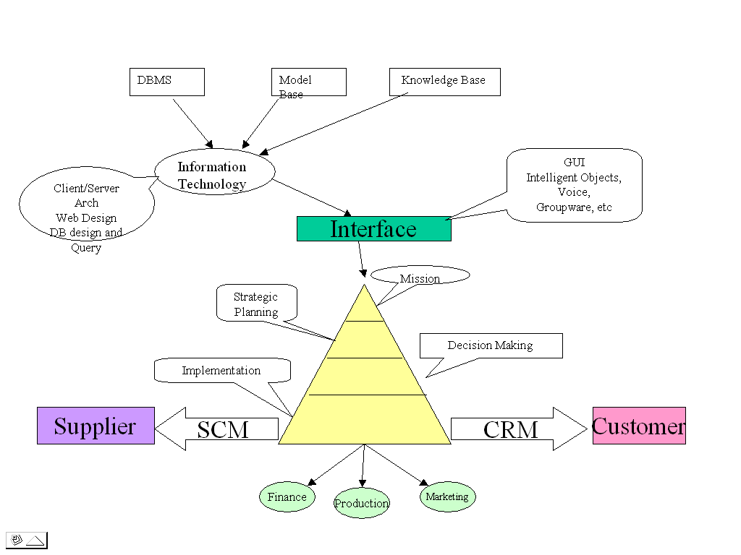
The integrated framework for utilizing Business Intelligence applications in the extended enterprise (SCM, ERP, and CRM) is shown in the following chart.

ERP
- Describe a Business Analysis framework for decision-making (Intelligence, Design, Choice) with reference to appropriate techniques, methods, and technologies.
The goal of Business Analysis is to gain insight from the key measures of the business, then put that insight into action to improve the business.
Intelligence
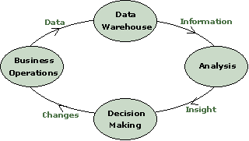
Design
Choice
The cycle begins with the day-to-day operations of the business, which generate data from processes. These data are either internal, such as revenues and orders, or external, such as survey results and demographic profiles.
The next step is to identify the key variables that will have great impact on how the business is doing. Once the key variables are identified, a data warehouse or data mart can be built. This organizes the necessary data from its various sources into one integrated information base.
After data are analyzed, an influence diagram will be drawn to show the relationships among the variables and output. Then a model is created to structure relationships, represent problem, and generate alternatives. To determine how sensitive the output is to the changes of key variables, sensitivity analysis and scenario analysis can be run to detect the dependency. If the distribution of the output is desirable, simulation analysis will be the best candidate. Goal-seeking analysis will help find out the best values for decision variables that will result in the desired output. The resultant answers from different analyses allow business analysts, managers and executives to look for trends, top performers, bottom performers, segmentations, correlations, etc. The reports will be stored in the report warehouse and document mart as a knowledge base for the future reference.
Decision makers would then be equipped with insights that they can use to strengthen weaknesses in the business. Solid information could support new or improved initiatives such as redefined goals, more efficient processes, targeted campaigns, and budget reallocations.
New initiatives change day-to-day operations, which in turn will generate different data. And, the cycle begins again allowing the business to continually monitor and assess its effectiveness.

